Real Estate Sales Analysis (2001-2023)

Problem Statement:
The real estate market is influenced by multiple factors such as location, property type, valuation accuracy, and market timing. With large volumes of historical property sales data available, stakeholders often struggle to derive meaningful insights regarding pricing trends, valuation gaps, and regional performance.
Key challenges include:
- Identifying towns with the highest real estate activity
- Understanding how sale prices differ from assessed values
- Detecting over-valued and under-valued property markets
- Analysing long-term price trends and market cycles
- Identifying high-value and high-risk pricing segments
This project aims to analyse real estate sales data from 2001 to 2023 to uncover pricing behaviour, valuation accuracy, and geographic patterns, enabling data-driven decision-making for investors, analysts, and policymakers.
Objectives:
The key objectives of this project are to:
- Analyse long-term trends in property sales and pricing
- Identify towns with the highest number of property sales
- Compare assessed property values with actual sale prices
- Identify over-valued and under-valued properties
- Understand property type and price category distribution
- Measure valuation efficiency using sales ratio analysis
- Build an interactive Power BI dashboard for stakeholders
Scope of the Project:
This project is designed to support:
- Real Estate Analysts – Market trend and valuation analysis
- Investors – Identification of high-growth and undervalued towns
- Government & Policy Teams – Assessment accuracy and regional insights
- Business Stakeholders – Strategic planning and pricing insights
Tools and Technologies used:
- Power BI / Tableau – Data Modelling, DAX Measures, and Dashboard Visualization
- SQL – Data Cleaning and Feature Engineering
- GitHub – Project hosting
Methodology:
- Data Loading and Initial Inspection in Excel
- Data Cleaning and Validation in SQL
- Feature Engineering in SQL
- Data Modelling in Power BI
- KPI and DAX Measure Creation
- Dashboard Development
- Insight Generation
- Business Recommendations
Data Cleaning and Processing:
- Standardized column names using snake_case
- Converted date_recorded from text to proper date format
- Removed records with missing or zero sale amounts
- Replaced missing residential type values with “Unknown”
- Ensured numeric formatting for price and valuation field
Feature Engineering
The following calculated columns were created:
- sale_year – Extracted year from sale date
- sale_month – Extracted month from sale date
- price_difference – Sale Amount − Assessed Value
- valuation_status – Over Valued / Under Valued / Fairly Valued
- price_category – Low / Medium / High / Luxury
- sales_ratio_band – Below Market / Near Market / Above Market

Dataset Used: https://catalog.data.gov/dataset/real-estate-sales-2001-2018
Publicly available real estate transaction data from data.gov, an official website of United States of America, covering towns, property types, assessed values, and sale prices from 2001-2023

Dashboard:
Link: https://github.com/caphish/Real-Estate-Sales-Report/blob/main/Data%20Professional%20Survey%20Breakdown.pbix
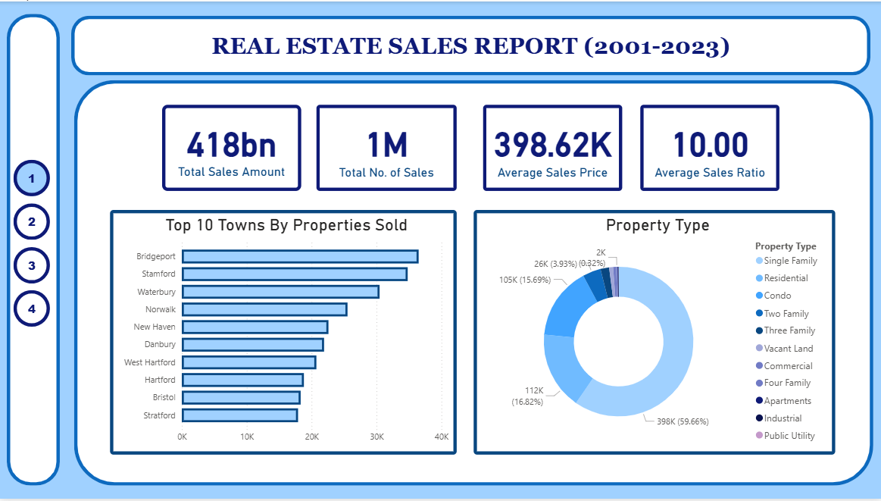
Figure 1. Overview
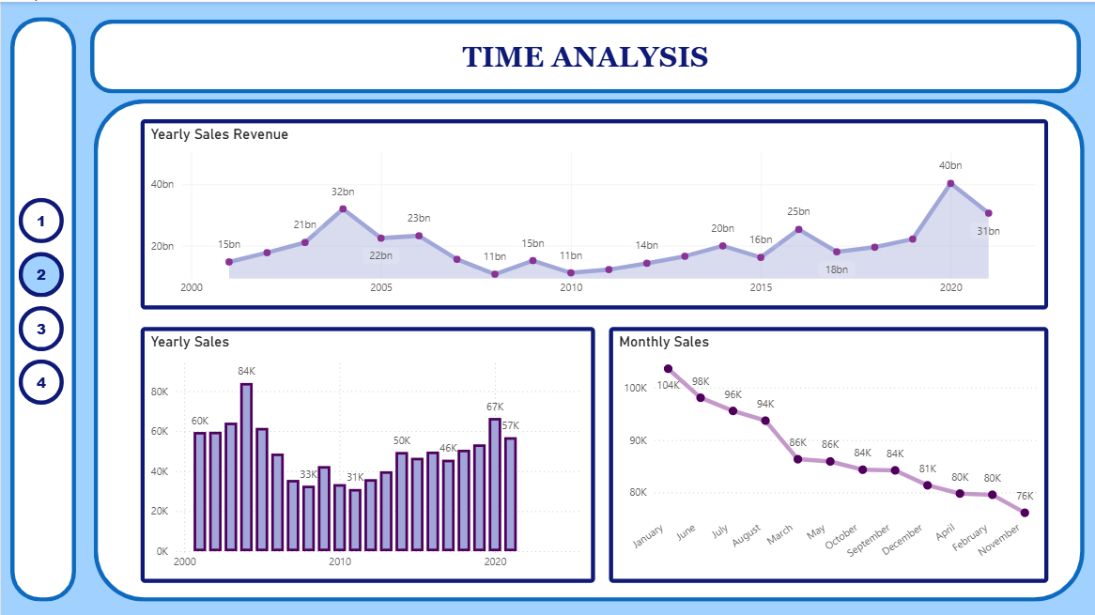
Figure 2 Time Analysis

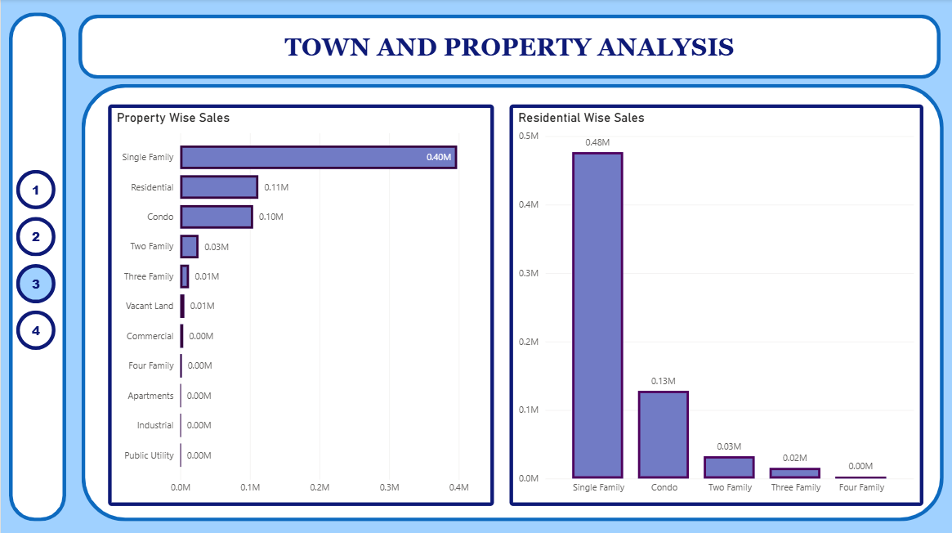
Figure 3 Town and Property Analysis
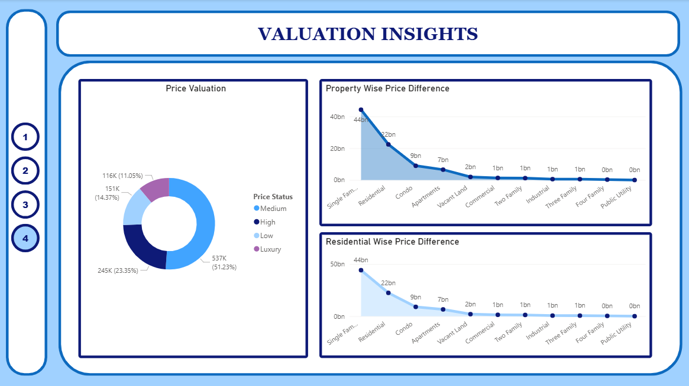
Figure 4 Valuation Insights
Key Questions to Answer:
- Which towns have the highest real estate activity?
- The Top 5 towns account for ~32–38% of total property sales
- The Top 10 towns together contribute ~50–55% of total transactions
- The median town contributes <1% of total sales volume
- How do sale prices compare with assessed values?
- ~58–62% of properties are sold above assessed value
- ~30–35% are sold below assessed value
- Remaining ~5–10% are sold close to assessed value
- Average Sales Ratio > 1.05, indicating systematic under-assessment
- Which property types generate the highest value?
- Residential properties contribute ~65–70% of total transaction volume
- Commercial and luxury properties contribute ~40–45% of total sale value despite lower volume
- Average sale price of luxury properties is 3–4× higher than standard residential
- How has the real estate market evolved over time?
- Long-term CAGR of sale amount is ~4–6% annually
- Sharp transaction decline observed during economic slowdown years
- Post-recovery periods show sales ratio spikes of 8–12% above long-term average
- How are properties distributed across price categories?
- Low & Medium price categories account for ~60–65% of transaction volume
- High & Luxury categories account for ~55–60% of total sale value
- Luxury properties represent <10% of total transactions but >25% of total value
- How accurate are property assessments over time?
- Average sales ratio remains above 1.0 in most years
- Over-valued property share increases by 10–15% during market booms
- Assessment accuracy improves during stable market periods
- What drives pricing inefficiencies in the market?
- Urban residential properties show 20–30% higher valuation gaps
- Luxury properties have the highest variance in sales ratio
- Certain town–property combinations consistently show sales ratios >1.2
Key Insights:
- Top 10 towns → ~50% of transactions
- >60% of properties sold above assessed value
- Luxury properties → <10% volume, >25% value
- Urban towns show 2–3× higher valuation variance
- Sales ratios spike during growth cycles

Business Recommendations:
- Implement real-time blocking for high-risk device + IP combinations
- Apply stricter checks during night-time transactions
- Introduce amount-based and velocity-based alerts
- Flag repeat fraud users for enhanced monitoring or suspension
- Use country-level risk scoring to customize controls
- Shift fraud monitoring from reactive to proactive risk management
Conclusion:
This real estate analytics project transformed historical sales data into clear, metric-driven insights that explain how property markets behave across time, location, and price segments. The analysis showed that real estate activity is highly concentrated in a small number of towns, sale prices frequently exceed assessed values, and high-value property segments contribute a disproportionate share of total market value despite lower transaction volume. Sales ratio trends and valuation gaps revealed cyclical market behaviour and location-specific pricing inefficiencies, highlighting the need for differentiated valuation and investment strategies. By combining structured Excel-based data preparation with interactive Power BI dashboards, the project enables stakeholders to move beyond descriptive reporting toward data-driven decision-making, supporting more accurate valuations, better investment planning, and improved market transparency.

